**ANNUAL TREE MORTALITY SURVEY_ ForestGEO-SCBI**

At the SCBI large plot, a blue re-bar located in the SW corner gives the quadrat names. Locate the rebar and orientate yourself. Locate trees within quadrat. Coordinates (x, y) are given in reference to a 20x20m square.

*Tree data (pre-existing data)*

**Codes 2013:** refers to stem conditions given in 2013 (last core census): **A**: alternate pom (point of measurement), **B**: stem broken above breast height, **C**: dead above 1.3m, **F**: Incorporated into fence, **G**: ID to Genus certain, **I**: stem irregular where measured, **J**: Bent, **L**: leaning stem, **M**: multiple stems, **main**; main stem, **P**: prostrate stem, **S**: secondary stem, **V**: Vine, **X**: stem broken below 1.3 m. Dead codes: **DS**: Dead, stem standing, **DC**: Dead, stem fallen, **DT**: Only tag found, **DN**: No plant nor tag found.

**DBH (mm):** Diameter at breast height in millimeters. Given for all trees as last core census.

**Live status in previous mortality census:** A (Alive), DS, DC, DN, and PD. PD: “previously dead”: tree found dead during a previous census. If the tree is found alive, change status and write in comments. If DN, try to relocate the tree again and indicate the FAD.

**New status**: use A, AU, DC, DS. There shouldn’t be a DN; you need to find all trees in the list. AU is used for trees that are alive but noticeably unhealthy (e.g. fallen and uprooted but not yet dead).

**PROCEDURE**

1. Locate all stems on datasheet and classify as “A”, “AU”, “DC”, or “DS”.
2. If the status is “AU”, record FADs in order of importance.
3. If a stem is dead:
   * **Pictures:** Take a picture of every dead tree found. Take tag picture first then make 2-3 pics of main FADS. Make close-ups if any insect or insect galleries are found.
   * Measure **DBH** (mm). If stem has fallen, measure it later using the big caliper.
   * Take 1 **core**, aiming to hit the center: only at breast height and for the following species: ceca, amar, cofl, ploc, prav, rops, saal, and all Quercus. Save these in straws for future analyses. Label each straw with tag #, species, and date.
   * Record **Percentage of crown** still intact:

1 = only 0-25% of the crown is intact (almost gone)

2 = 26-50% of the crown is intact

3 = 51-75% of the crown is intact

4 = 76-100% of the crown is intact (none or few branches lost)

* + Record **Crown Position:**

*Dominant* (**D**): Crown extends above the general level of the canopy receiving full sunlight.

*Codominant* (**CD**): Crown forms main level of canopy, tree receives full sunlight from above.

*Intermediate* (**I**): Shorter trees with smaller crowns, receive little light from above and none from sides.

*Suppressed* (**S**): Crown below canopy, small crown receives no direct light.

*Open grown* (**OG**): Crown on open areas of the stand.

* + **Liana load.**

0 = lianas absent

1 = up to 25% of the tree crown covered by lianas

2 = 26–50% liana cover

3 = 51–75% liana cover

4 = 76–100% liana cover.

* + Record **FAD** (Factors associated with death) in order of importance.

To scrutinize the FAD’s look at “*Guide to Identify Tree Diseases at the SCBI-CTFS Forest-GEO Plot*”.

|  |  |
| --- | --- |
| **FAD Categories:**  **U**= Unable to determine cause of death  *Mechanical damage*  **B**= Broken stem (note cause, indicate level on tree)  **CR**= Crushed by other tree or tree parts  **UP**= Uprooted tree (root bole exposed)  **S**= Slope failure (evident landslide even if small)  **L**= Lightning (tree splitting, straight scars from above)  **Fi**= Fire (stem charred, fire scars on bark) | *Biological agents*  **AN**= Animal damage (specify animal if possible)  **BB**=Bark beetles present, beetle galleries.  **I=**  Insect infection (e.g. EAB, other)  **DF**= Complete defoliation / Smith/Flower 2013 rating for AU  **F**= Fungi visible (give names if known)  **K**= Canker or swelling present (cause by fungi)  **LF**= Leaf damage (look for leaf spots, blotch, etc.)  **R**= Rotting stem.  **R1**= Root damage  **R2**= Armillaria root disease |

1. For *Fraxinus* species and trees code chvi: All trees ≥1 cm will be visited during a mortality survey.

* Record **crown position** (D, CD, I, S or OG. see above)
* Estimate **crown thinning** via visual assessment per Smith/Flower 2013:

1 = healthy tree with no symptoms of decline, no defoliation

2 = slight reduction in leaf density (thinning), yet all top branches exposed to sunlight have leaves

3 = thinning canopy and some top branches exposed to sunlight are defoliated (<50% dieback)

4 = >50% defoliation/dieback

5 = Dead tree with no leaves in canopy (excluding epicormic sprouting)

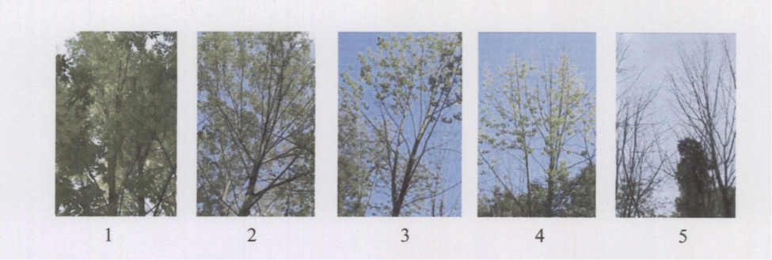

* **Epicormic shoots**: Use the 6-class dwarf mistletoe rating system (Hawksworth 1977) to evaluate epicormic growth

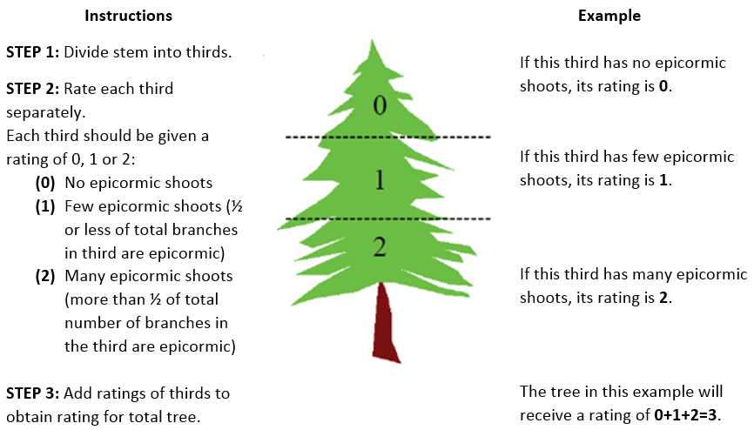

* Record **EABF** (EAB Factors)

VB = Vertical bark splitting

SS = Stump sprouts

AS = Ash snap of the branches/limbs

W = Bark blonding from woodpecker predation. In comment section, write percentage estimate.

DE = D-shaped exit hole presence

* 1. Count visible D-shaped exit holes around the circumference of the tree in an area about half of a meter long at breast height and record this for every ash tree.